V-TWIN 20W/40  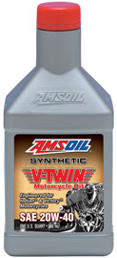  APPLICATIONS  AMSOIL 20W-40 Synthetic V-Twin Motorcycle Oil is recommended for air- or liquid-cooled Victory or Indian and other four-stroke motorcycles calling for a 20W-40 motor oil. It meets API SM, JASO MA and API GL-1 specifications, providing outstanding protection for engines and transmissions.  SERVICE LIFE  For on-road use in engines and transmissions, AMSOIL 20W-40 Synthetic V-Twin Motorcycle Oil and AMSOIL Ea® Motorcycle Oil Filters are capable of providing premium protection for up to 2X the motorcycle manufacturer-recommended change interval or one year, whichever comes first. Change other brand oil filters at standard intervals.  For off road use change at owners manual recommendation.  For racing application there is no recommendation, oil change is at owners discretion. | V-TWIN PRIMARY FLUID  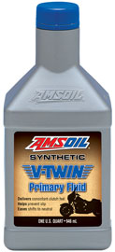  APPLICATIONS  Harley Davidson®, Triumph® and pre-2013 INDIAN® bikes  DRAIN RECOMMENDATIONS  V-Twin Synthetic Primary Fluid is recommended for up to 10,000 miles or one year, whichever comes first.  Delivers Consistent Clutch Feel & Smooth Acceleration  V-Twin Synthetic Primary Fluid is formulated with a balanced additive system that provides consistent clutch performance and feel. It helps riders easily find neutral and promotes smooth acceleration, whether in stop-and-go city conditions or when on the highway. Its superior load-holding capacity helps prevent clutch slip for confident takeoffs.  WARRANTY SECURE™ | V-TWIN TRANSMISSION FLUID  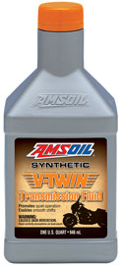  APPLICATIONS  Harley Davidson®, Triumph® and pre-2013 INDIAN® bikes.  DRAIN RECOMMENDATIONS  V-Twin Synthetic Transmission Fluid is recommended for up to 20,000 miles or one year, whichever comes first.  Promotes Quiet Operation  V-Twin Synthetic Transmission Fluid promotes formation of a durable oil film on bearings and gears, helping to dampen loud thunks when shifting and reduce gear noise.  Delivers Smooth Shifts  V-Twin Synthetic Transmission Fluid’s finely tuned viscometrics and frictional properties provide smooth shifts, helping riders avoid missed shifts for crisp acceleration through each gear. It provides riders confidence that their transmission is going to respond as intended for an improved ride.
PREPARED BY AMSOIL DIRECT JOBBER, CHUCK GUTLEBER, 267-278-3556 – www.FactorySynthetics.com

